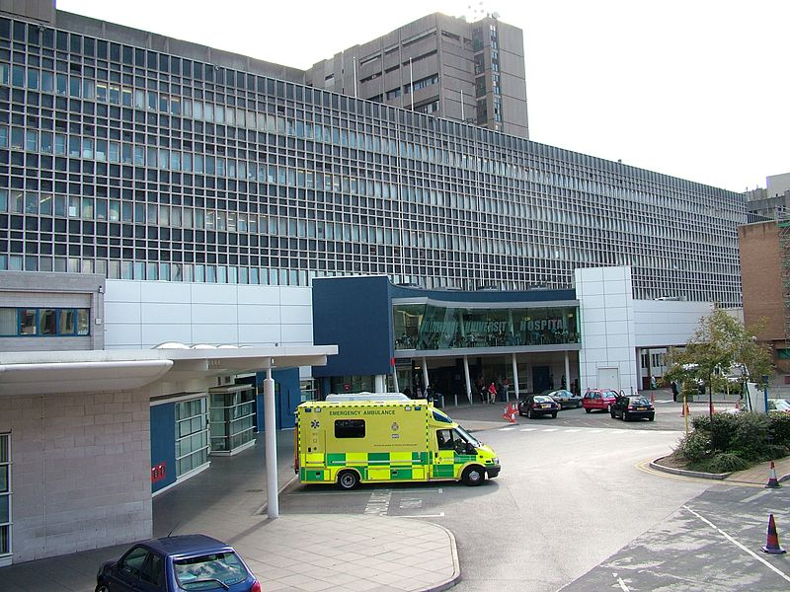

TO

WELCOME

LUH
TEMPORARY STAFFING

Welcome to LUH’s Temporary Staffing Service
Welcome to the Temporary Staffing Team at Liverpool University Hospitals. You are joining a dedicated and skilled team of temporary workers who provide a high quality service to all areas of the Trust
This booklet is designed to assist you in understanding the procedures of the Bank, and to prevent potential problems arising. We ask all bank staff to familiarise themselves with the information contained in this document
Temporary Staffing workers are a crucial part in ensuring that our Trust is the best it can be. Every individual who signs up to work for the service plays their part in improving the stay of our patients and as a bank worker, we recognise just how invaluable your flexible approach to work is.
As a temporary worker, you will provide ad-hoc cover to areas across a range of specialisms within the Trust. You will have the chance to experience life in different departments, learning how different specialisms operate; you will work with lots of people and you will get the opportunity to get an insight into any area you choose if they have work available.
The importance of our bank workers bringing this flexibility and willingness to move across areas to the Trust is invaluable to our wards and departments in their endeavours to maintaining the exceptional levels of care and support that our patients receive.
Our friendly office teams are available to help you with a variety of things while you are working via Temporary Staffing. We will support you with arranging your bookings, providing your training and a whole host of other things.
Finally, we would like to thank you for deciding to join our team of skilled, proactive and dedicated bank workers deployed across our organisation and we look forward to getting to know you in the future.
Don’t delay, book today!
LUH Temp Staffing Team

GENERAL INFORMATION AND FAQ’s

Temporary Staffing Department Opening Times:

Our Temporary Staffing Teams are based at two of our sites, one at Royal Liverpool and one at Aintree Hospital.

You are able to get in touch with the team during the hours listed below:

Monday - Friday | 8am – 5pm
Saturday & Sunday | 9am – 3pm

The Temporary Staffing Team at Royal Liverpool is based on site in the main building of the hospital on the first floor near the Chapel and the team at Aintree Hospital are based in Cherry Tree House on the old part of the site.

Although both teams are available throughout the day via phone and email.

Wherever possible, we would ask that given the pandemic, you only attend either of our offices on an appointment basis to ensure that we are able to adhere to the government guidance around social distancing and reducing social contact.

Contact Us:

With over 3000 bank workers, we get a lot of people contacting us! To support this, we have got various outlets for you to get in touch:

Temp Staffing Team | Tel: 0151 529 6999  Email: tempstaffing@liverpoolft.nhs.uk  Facebook: @LUHFTBank

Although the Temporary Staffing Team will aim to support you with any enquiries you have, the team do not facilitate payroll and will only be able to offer you a limited amount of advice as it is your responsibility to ensure your shifts are finalised within the appropriate time frame.

Social Media

The Team has its own Facebook page which we would love you to join. The pages will offer our staff important updates and information about the Trust and the department and gives us another way to keep in touch.
The page is available by searching for either @LUHFTBank or by looking for ‘Liverpool University Hospitals FT Temp Staffing’.
The page has regular updates from the team including important messages from our senior colleagues; important communications and updates from the team as well as information about which areas need your help!
Although the page does have a messenger function which we monitor, we would encourage you to contact us via email in the first instance to ensure that we do not miss anything you send through.
Please remember, we cannot accept cancellations through this portal and if you wish to book a shift you should check your Employee on Line for vacant duties or give us a call.
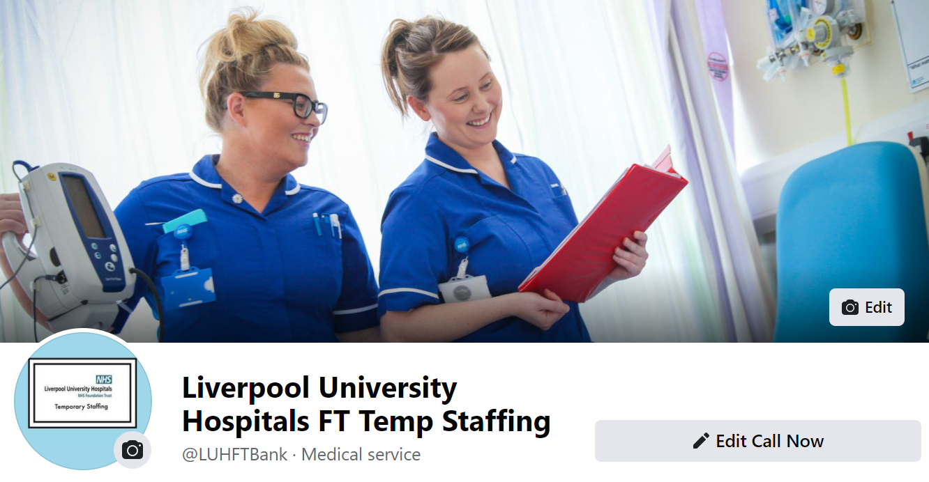
Training

It is your responsibility to ensure that you maintain compliance with your mandatory training. As part of your on boarding process when joining the Trust, you should have been given access to ESR Self-Service which will allow you to complete the online learning modules and to keep abreast of any lapses in compliance. If you did not get an ESR Self- Service login, you should contact the Temporary Staffing Team.
If you are non-compliant, you will not be able to work so it is incredibly important to ensure that you are aware of when your training needs to be renewed and to proactively complete modules before they expire.
In addition to those modules that you can complete through ESR Self Service, there are certain courses for which you will need to attend a face to face session at the Trust. Your ESR Self-Service will notify you of when these are due to expire and at least three months before they lapse, you should proactively contact the Compliance Team to arrange a suitable time to complete the course.
If for whatever reason you are unable to attend your training, you must give both Learning and Development and Temporary Staffing at least 48 hours’ notice, failure to do this could result in you being charged for your training. For any training enquiries please email training.tempstaffing@liverpoolft.nhs.uk
Uniforms and ID
As a valued member of our Trust, our bank staff should wear their LUH uniforms with pride! Remember, wearing your nursing tunic or admin uniform associates you with our organisation and we want the world to know we have pride in what we do. This means that wherever possible you should ensure that if you are clinical, you should only wear your uniform in clinical areas – avoid wearing this in public. When on shift, your uniform must be laundered and clean at all times and if you smoke, please do not do this in your uniform!
When on site, you should always have your ID Badge visible and be willing to challenge staff who do not have theirs on display. This helps our colleagues and patients know who we are as it is likely that as bank workers you will be spotted all over the Trust, bringing your skills into an area to provide much needed support.
Uniformed Staff - Clinical

Royal and Broadgreen Site

Uniforms for clinical Staff will be ready to collect following the completion of all mandatory training. They will be available to collect from the Linen Services Department based on the lower ground floor of the Royal Liverpool Site between 10.30am-13.30pm. For existing staff, should you require a new uniform due to them being damaged or if they no longer fit please contact our department so we can order this for you.
Guidance for Clinical Non Uniformed Staff, Non Clinical Uniformed and ununiformed staff can be found on our Trust intranet on the below link.
http://rl-faq.nhs.sitekit.net/employee-relations-direct/employee-relations.htm

This is section is likely to be updated, following upcoming Trust changes

Aintree site

Uniforms for clinical Staff will be ready to collect following the completion of all mandatory training. In order to request a uniform you should complete a uniform request form which will be given to you during your bank induction. If you know your sizes and the Temporary Staffing team have this in stock, the team will be happy to issue them from Cherry Tree House. If you are not sure of your size and would like to be measured, you should return your uniform request form to the sewing room where one of the team will measure you. You should then return this to Temporary Staffing for the team to issue your uniform. If the team does not have your size in stock, you will be issued with a temporary set of scrubs which need to be returned before your uniform is issued.

Annual Leave

As a bank worker you will accrue 1 hour of annual leave for every 8.64 hours worked. This will auto calculate in the system and you are able to request your annual leave balance by contacting the team. You are able to claim this via a request form which should be returned to tempstaffing@liverpoolft.nhs.uk.

Before your first shift
There are a few things we need you to before you start your first shift with us, these will help you settle into life at the Trust quickly and will make sure that you are ready to go from your first day on the wards/department
Before working your first shift, you must complete all of your Mandatory Training; this includes the induction which OD has emailed you about and all of the modules which are on your ESR profile. If you are unsure of how to access, these please contact training.tempstaffing@liverpoolft.nhs.uk and we will help.
- If you are joining us as a HCA, you should liaise with our Training Coordinator to arrange your shadow shifts – further information on how you book these is discussed in our induction video.
- You should arrange to get your ID Badge prior to your first shift. You will need to collect your ID badge from the general office on the Aintree site. If you are working an early, you should attend at least 24 hours before the shift.
- Ensure you have either a Trust uniform or scrubs to attend your first shift (or if you are joining us in a role which does not require a uniform, dress to impress!)
- If you require parking, you should speak to the team in General Office who will be able to help you arrange this.
- Read through this handbook and familiarise yourself with some of our local processes.
- On each shift you attend on a different ward area, you must ask the department to complete a local induction checklist. You should then take a photo of this and email it through to tempstaffing@liverpoolft.nhs.uk

Frequently Asked Questions

As a bank worker, am I entitled to enhancements on my hourly rate?
The good news is you are!
Band 2 | Night | Time +43%
Band 2 | Saturday | Time + 43%
Band 2 | Sunday/BH | Time + 85%
Band 5 | Night | Time + 30%
Band 5 | Saturday | Time + 30%
Band 5 | Sunday/BH | Time + 60%
Saturday nights will be paid at a split rate. The first 4.5 hours at Saturday rate and the next 7 hours at Sunday rate.
As a bank worker, am I entitled to sick pay?
Working via the bank means that you are employed on a casual worker agreement. As a casual worker in the Trust, you are not obligated to work and the Trust is not obligated to offer you work. However, if you are unwell and you have the appropriate earnings, you are entitled to Statutory Sick Pay which the team will be happy to help you with.
As a bank worker, am I entitled to maternity pay?
When you are ready to go on your maternity leave, you should link in with your Temporary Staffing Team to discuss your options around maternity. Although you are not entitled to occupational maternity pay, there may be something we can help you with.
Can I work Night Shifts?
You can only work a night shift once you have completed 10 day shifts, a long day equates to two shifts.
Why have I been asked to move during my shift?
As a bank worker you have been booked on to your shift to help an area that has a shortage of staff. If you are asked to move it is because an area has become even more in need than the one you are on. We will only ever ask staff to move as a last resort but when we do, it is because your help is essential to the area you are being moved to.
Is there parking available?
On our Aintree site, bank staff are able to park on any of the available staff parking areas which are clearly marked. There is a charge for this though, so it is important that if you do want to drive to work and park up, you speak with the sites General Office Team who will be able to help.
On our Royal site, parking is very limited and as we suggest wherever possible, you should try to utilise other methods to get to work. There is waiting list for staff to access parking permits however this is quite extensive but if you wish to be added to the waiting list, you can speak with the sites security department.
How often do I need to work before my bank assignment becomes inactive?
We need our bank staff to complete at least one shift every 12 weeks to remain on the bank. If you do not do this, your post will automatically become inactive. However if you let us know that you are not going to be available for a period of time, we can review this and do our best to keep your post open.

Aintree Site Maps
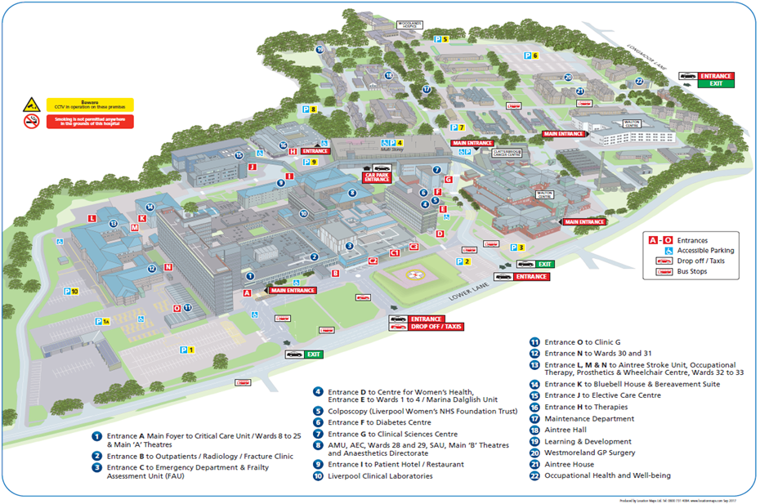

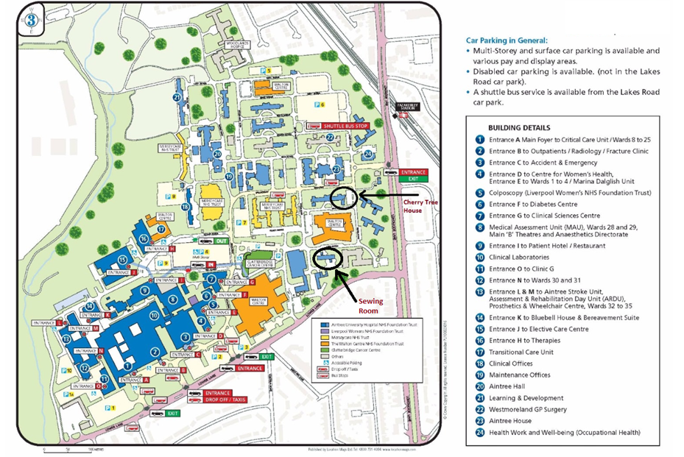

Booking your shifts

Booking Shifts:

Across our sites, bank workers are able to view and book bank shifts online. Allocate Me, the online Roster portal gives those staff who wish to book onto shifts access to 8 weeks’ worth of available shifts across the site and these can be booked with the click of a button.
If you would like to register to access your own shifts online, please email eol.tempstaffing@liverpoolft.nhs.uk after you have completed your shadow shifts and an account will be created for you.
Allocate Me is available for use both inside the hospital and from home. To access Employee on Line from home, you should download the ‘Me’ App from the App Store or Play Store.
To access the EOL internally please use:
https://luh.allocate-cloud.co.uk/EmployeeOnlineHealth/LUHLIVE
Please see the brief guide on how to book shifts below:
VIEWING AVAILABLE SHIFTS
When you login to EOL, select from the left hand menu. You will see unfilled shifts from TODAY looking forward 8 weeks.

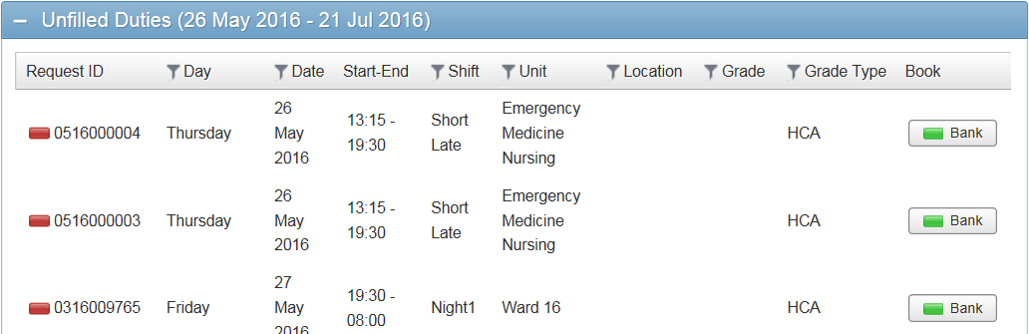

It is important to remember the following when booking shifts. It is the intention of the TRUST that all rosters will be approved 8 weeks prior to work. It will take some time to achieve this so in order

to avoid changes / cancellation to your bookings, please ensure that you have factored your substantive duties into your planned work.
You will know whether you have substantive shifts booked by selecting from the left hand menu.

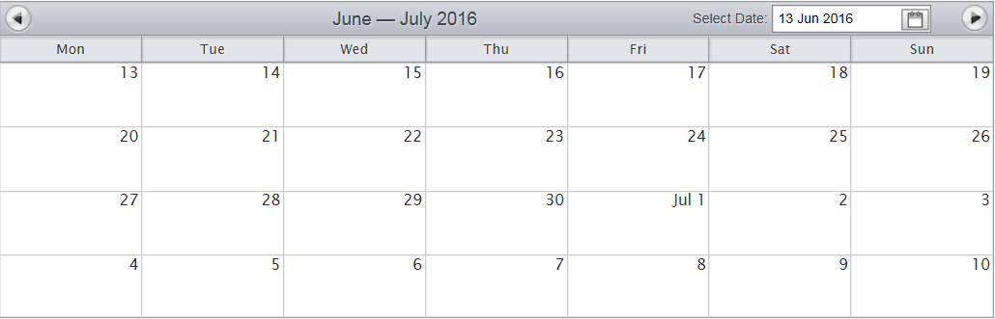

BOOKING A SHIFT
Once you’ve decided which shift you are prepared to work, select the respective button & the following message will appear

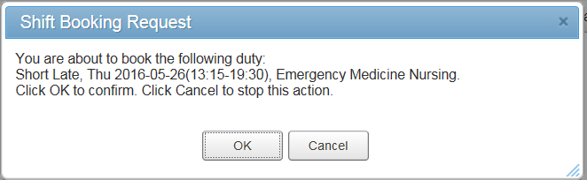

Review the details & select

If all the conditions match correctly the booking will be successful & will be reflected in

TROUBLESHOOTING

If you receive the following message or any issues whilst booking, please contact the team on 0151 529 6999

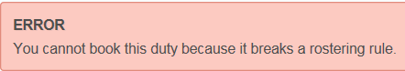

In addition to booking shifts, Allocate Me allows you to check which shifts have been finalised and will be processed for payment.
If you see the shift appears with a green box, the shift has not been finalised and you should contact the ward manager and ask them to finalise it as failure to do this could result in underpayment. It is your responsilbilty to ensure that your bank shifts are finalised for payment. The Temporary Staffing Team can only process finalised hours.
If the shift appears with a padlock then it has been finalised and will be processed for payment.
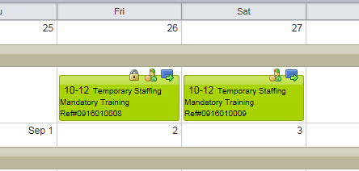
If your shift does not appear on the system you will need to get the Ward Manager to add the shift, the Temporary Staffing Team cannot do this for you.
In addition to Allocate Me, you are able to book shifts via a phone call to the Temporary Staffing office. The team will offer you a variety of wards should they be available and you are able to select the ward you would most like to work on.
If you accept a shift you will receive a text message confirming this and shortly before your shift starts you will receive a text reminder.
Across our sites, there may be occasions that you will be asked to support a priority area either before or during your shift and your support in this would be gratefully received.
Our shift patterns are devised to support the complex needs of our wards and should be accepted as rule. You must arrive at the notified start time.
We must remind you that the Trust does not pay breaks. This means that on any shift over 6 hours, you must take an unpaid break of at least 30 minutes as the roster system automatically deducts this time from any pay due for that shift, this is really important as you will need a rest!
If you are work a long day or a night shift, you must take a 60 minute break.
Admin shifts are requested by Admin managers directly through Temp Staffing. The team will co-ordinate these requests and contact suitable staff to fill the applicable staffing gap and if you are an admin worker, you will likely be in regular contact with one of us to discuss your placements. Please note that in the most part if you are a clerical worker, you will be booked directly in to shifts by the manager in your area, meaning you will not need to use Employee On Line to secure your bookings.

You are required to sign in and out of your shift on a register readily available in the department you work in. It is your responsibility to ensure you sign in and out of your shift and to make sure that your shifts are locked down by the departments. As the money for your shift comes directly out of the ward budget, it is up to the team on that area to approve for you to be paid. We send out regular reminders to wards to ask them to finalise duties, but it’s important that you keep an eye on your Employee On Line to ensure this is done, as if it is not you won’t be paid.
Any payment queries regarding shifts worked are to be redirected to the supervisor/manager in the department you work in not the bank office to correct.
Cancellations

If you wish to cancel a shift, it is still imperative that you contact the Temporary Staffing office to let the team know as far in advance as possible, this will give the team the best opportunity to find another worker to shift. You must also contact the ward and let the nurse in charge that you are unable to attend, giving your reason why.
Wherever possible you must give a minimum of 24 hours’ notice of cancelling a shift. If you repeatedly cancel shifts at short notice you will be restricted from working from the Trust until you have met with the one of the management team from the Temporary Staffing Service. If late cancelations continue after the meeting the offer of work will be withdrawn.
Please note, once you have booked a shift you are considered a member of the team for that duty and you are not able to swap wards at the last minute as this could result in staffing concerns within the Trust.
Failure to arrive for any shift without advising either Temporary Staffing or the ward will result in instant restriction from duties after which you will be asked to attend a face to face meeting with the Temporary Staffing Manager.
We do monitor staff against their DNA’s and cancellations and it is important that issues like these could result in your removal from the bank.
Working Time Directive

Under the Working Time regulations the maximum weekly working time (including bank shifts) is an average of 48 hours calculated over a period of 17 weeks; this includes time worked when on annual leave. The maximum average number of weekly working hours across a 17 weeks period is 56 and you cannot opt out of this.

Workers who work additional work outside of their bank hours at LUH must advise the Temporary Staffing Teams in writing and keep us posted about how many hours they are working per week; this is to ensure we are supporting you as workers and protecting the needs of our wards and departments. Please remember, you are not allowed to exceed the working time regulation 48 hours maximum.

Pay Dates
Bank workers are paid weekly, one week in arrears. The working week runs from Monday to Sunday and shifts must be finalised by 9am each Monday. If this happens, you will be paid for these duties the following Friday.
Please note when you first join the bank you will not be paid for 2 weeks after we receive approval to pay you for your first shift. After that it will revert to weekly pay.
It is your responsibility to ensure that shifts are finalised and you can check this via Employee On Line. All finalised shifts will show the padlock symbol next to them. If your shift is not finalised or not showing on EoL, you should contact the ward before 9am on a Monday to arrange for this to be actioned. The Temporary Staffing Team will support with this by sending out regular reminders to managers but they cannot add, amend or finalise any duties on their behalf.
Any shifts which remain unfinalised after 9am will be processed for pay in the next run if they are processed by the ward.
Pay Slips
The Trust is now payslip free and you are able to access your payslip through ESR on your phone. These appear weekly and it’s really important that you ensure you are accessing the correct payslip by checking the pay date and your assignment number on the app, before contact the team or payroll.
If you do have a pay query you should first check your Employee On Line to ensure your shift has been finalised correctly and if it has and your pay still appears to be incorrect, you should contact STHK, our payroll provider on 0151 290 4938 or at weeklybank@sthk.nhs.uk.
Our Expectations
As a new starter on the Temporary Staffing register, the opportunities for you are endless. From building relationships with staff across the Trust to having the opportunity to build experience in a diverse range of wards and departments this is a great opportunity for you to have an impact on the health and wellbeing of patients in our three amazing hospitals.
With this comes responsibility, our bank workers are expected to adhere to all of our internal policies and procedures particularly around uniform, behaviour and conduct, infection control, training compliance and social media and mostly to show pride in what they do.
The team are here to support you and will do whatever they can to give clarity and ensure that your experience of working on our bank is an enjoyable one and we understand that at some point, as with any job, you may become frustrated but please remember we expect you to always speak to us with courtesy and any unprofessional behaviour will not be tolerated.
We are really looking forward to working with you and wish you the best of luck in your career at Liverpool University Hospitals.

